

Capstone Project Report
Student Management System

Group Members:
Name of the Student | SAP ID | Batch
Sharanya Mahajan | 590012704 | 12
Sanvi Chawla | 590018244 | 12
Prisha Pokra | 590013227 | 11

Submission Date: 01.05.2026

Project Overview
Problem Statement
Managing student records manually using registers or spreadsheets is inefficient and prone to errors. In many institutions, maintaining records manually leads to data redundancy, loss of information, and difficulty in retrieving specific records.
This project aims to solve these problems by developing a Java-based Student Management System, which allows users to manage student records digitally in a structured and efficient way.
Key Problems Identified:
- Manual record keeping is time-consuming
- High chances of human error
- Difficulty in searching and updating records
- Lack of data security and persistence
- Duplicate entries and inconsistent data

Scope of the Project
The scope of this project includes developing a desktop-based application that allows users to perform basic operations on student records using a graphical interface.
The system will:
- Provide a user-friendly GUI for interaction
- Store student data in a database for permanent storage
- Allow CRUD operations (Create, Read, Update, Delete)
- Validate user inputs to ensure data correctness
Limitations:
- No login/authentication system
- Single-user system
- Limited to basic student details (roll number, name, course)

Objectives
The main objectives of this project are:
• To develop a Java-based application using Swing GUI
• To implement Object-Oriented Programming concepts effectively
• To provide efficient operations like add, delete, search, and display
• To implement proper validation and exception handling

3. Requirement Analysis

3.1 Functional Requirements
Functional requirements define what the system should do. The system must provide the following functionalities:
Core Functionalities:
• Add new student records into the system
• Delete existing student records using roll number
• Search for a specific student using roll number
• Display all student records in a structured format
Validation Features:
• Ensure roll number is greater than zero
• Prevent duplicate roll numbers
• Validate that name and course contain only alphabets
• Ensure no field is left empty
Output Handling:
• Display success and error messages
• Show results in the output area
• Provide clear feedback to the user

3.2 Software Requirements
The following software tools and technologies are required to develop and run the project:
Development Tools:
• Java Development Kit (JDK 8 or above)
• Integrated Development Environment (IntelliJ / Eclipse / NetBeans)
Other Tools:
• Git and GitHub for version control
• Operating System (Windows/Linux/Mac)

4. System Design

4.1 Module Description
The project is divided into different modules to ensure proper structure and maintainability.

🔹 GUI Module (StudentGUI)
This module handles all user interactions. It provides input fields and buttons for performing operations.
Responsibilities:
• Accept user input (roll number, name, course)
• Display results in a text area
• Provide buttons for operations (Add, Delete, Search, Show All)
• Handle user events using action listeners

🔹 Business Logic Module (StudentManager)
This module contains the core logic of the system. It processes data and interacts with the database.

Responsibilities:
• Validate input data
• Perform operations like add, delete, search

🔹 Data Model Module (Student, Person)
This module defines the structure of student data using classes.
Responsibilities:
• Represent student data as objects
• Implement encapsulation using private variables
• Provide getter methods
• Use inheritance (Student extends Person)

🔹 Exception Handling Module
This module ensures that errors are handled properly.
Responsibilities:
• Handle invalid input using StudentException
• Handle SQL exceptions
• Display meaningful error messages

4.2 Simple Flow Diagram
The system follows a simple flow of operations:
Start
↓
Launch Application (GUI)
↓
User Enters Details
↓
User Selects Operation
↓
[Add / Search / Delete / Show All]
↓
System Processes Request
↓
Display Result
↓
Exit

4.3 Database Design
The system uses a single table to store student records.
Table Name: students
Field Name | Data Type | Description
rollNo | INTEGER | Primary Key (Unique ID)
name | VARCHAR / TEXT | Name of the student
course | VARCHAR / TEXT | Course enrolled

5. Implementation

5.1 Technologies Used
The following technologies are used to implement the system:
• Java (Core Programming Language)
• Swing (GUI Development)
• Git / GitHub (Version Control)

5.2 GUI Description (Screenshots)
The graphical user interface consists of the following components:
Screens to include:
• Main application window
• Input form (roll number, name, course)
• Add operation result
• Search result display
• Delete confirmation message
• Show All records display

5.3 Important Code Snippets
- Add Student:
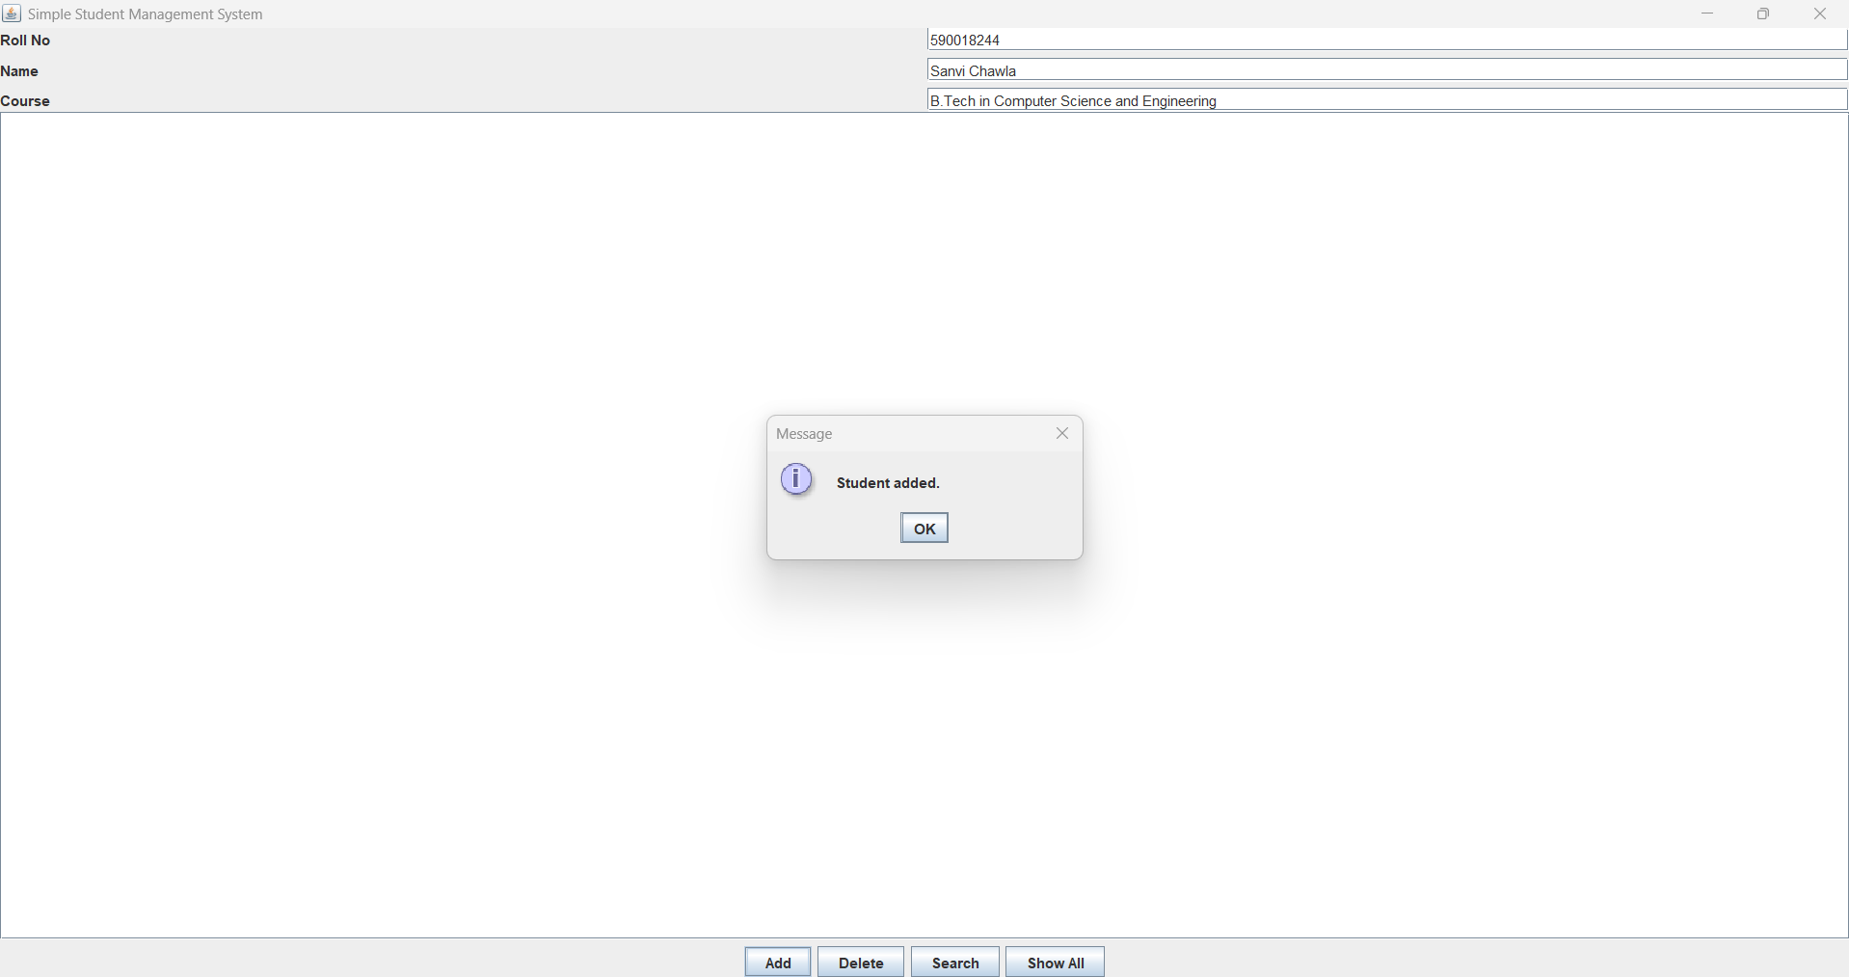

- Delete Student:

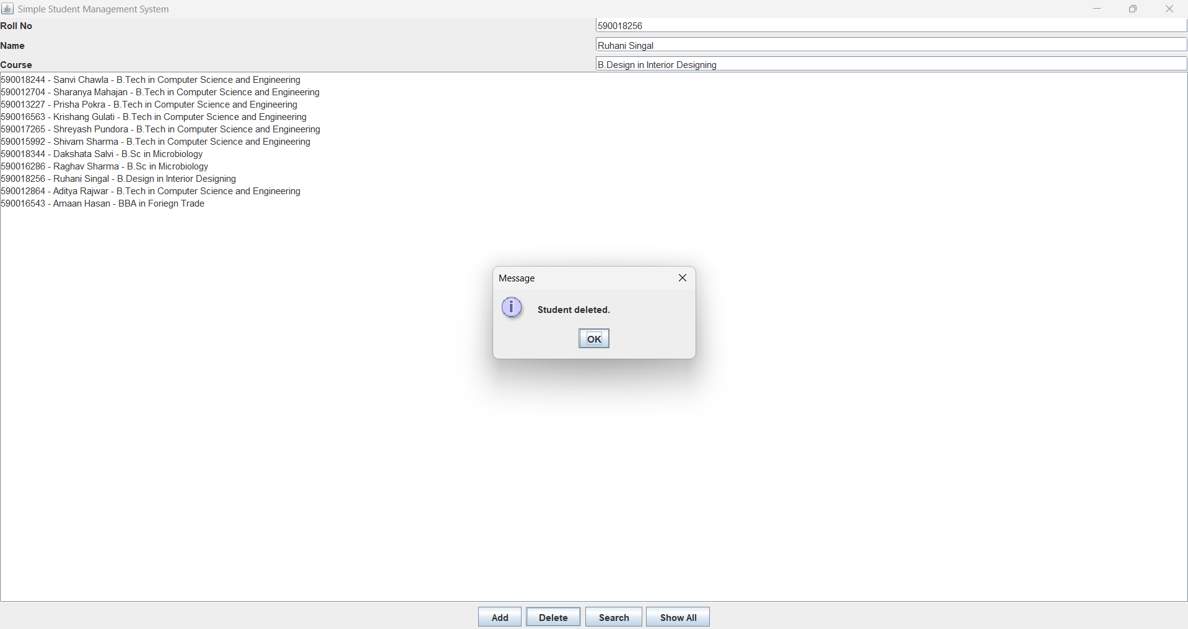

- Search Student:

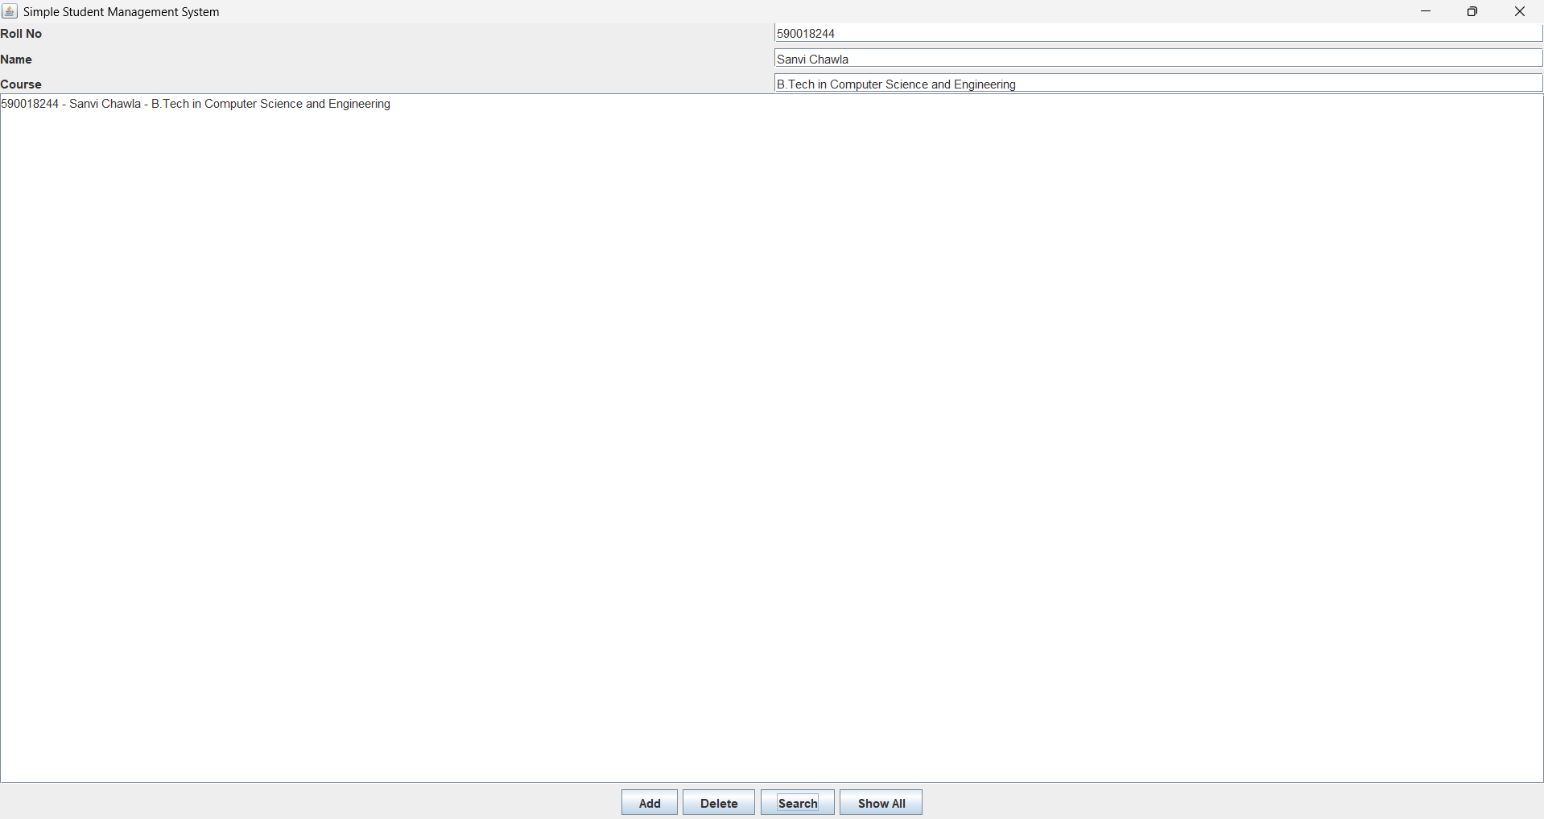

- Show All Students:



🧠 OOP Concepts Used
The project demonstrates strong implementation of Object-Oriented Programming concepts:

🔐 Encapsulation
Encapsulation is achieved by:
• Declaring variables as private
• Providing getter methods
• Restricting direct access to data

🎭 Abstraction
Abstraction is implemented using:
• Abstract class Person
• Abstract method getDetails()

🧬 Inheritance
Inheritance is used by:
• Student class extending Person
• Reusing common properties like name

🎨 Polymorphism
Polymorphism is demonstrated by:
• Overriding the getDetails() method
• Providing specific implementation in Student class

⚠️ Exception Handling
The system includes proper error handling mechanisms:
• Custom exception (StudentException) for validation errors
• Try-catch blocks for handling SQL exceptions
• User-friendly error messages

🔗 6. GitHub and Version Control

6.1 Repository Link
(Add your GitHub link here)

🎯 Final Conclusion
This project successfully demonstrates the development of a Student Management System using Java and database integration.
Key Achievements:
• Automated student record management
• Applied OOP principles effectively
• Integrated GUI with database using JDBC
• Ensured data validation and error handling
• Provided a simple and user-friendly interface
The system improves efficiency, reduces manual errors, and provides a scalable solution for managing student data.

